Appendix 1:
List of Prompts Used

Rubric for List of prompts used

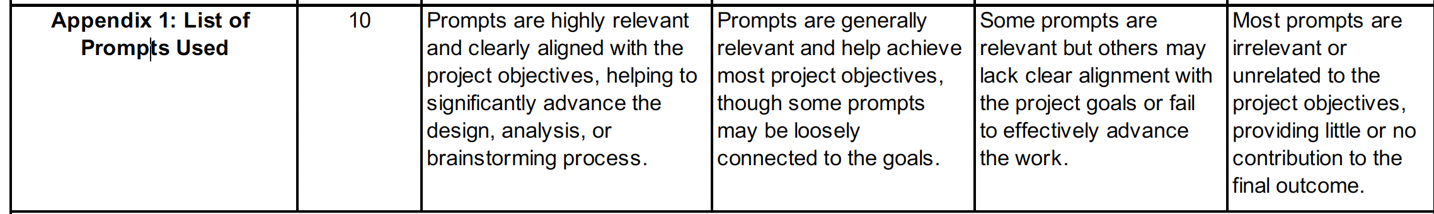

Notes:
The purpose of Appendix 1: "List of Prompts Used" is to showcase the student's ability to effectively utilize prompts relevant to achieving the project's objectives.

For instance, in a system-development project, the objectives may include eliciting requirements for the proposed system, analyzing and designing its architecture, and developing and testing the system. Therefore, the appendix should illustrate how prompts were used to brainstorm project ideas and work toward these objectives.

Examples of Ineffective Prompts (Poor-scale rubric)
- https://typeset.io/search?q=chatbot%20in%20sales%20marketing

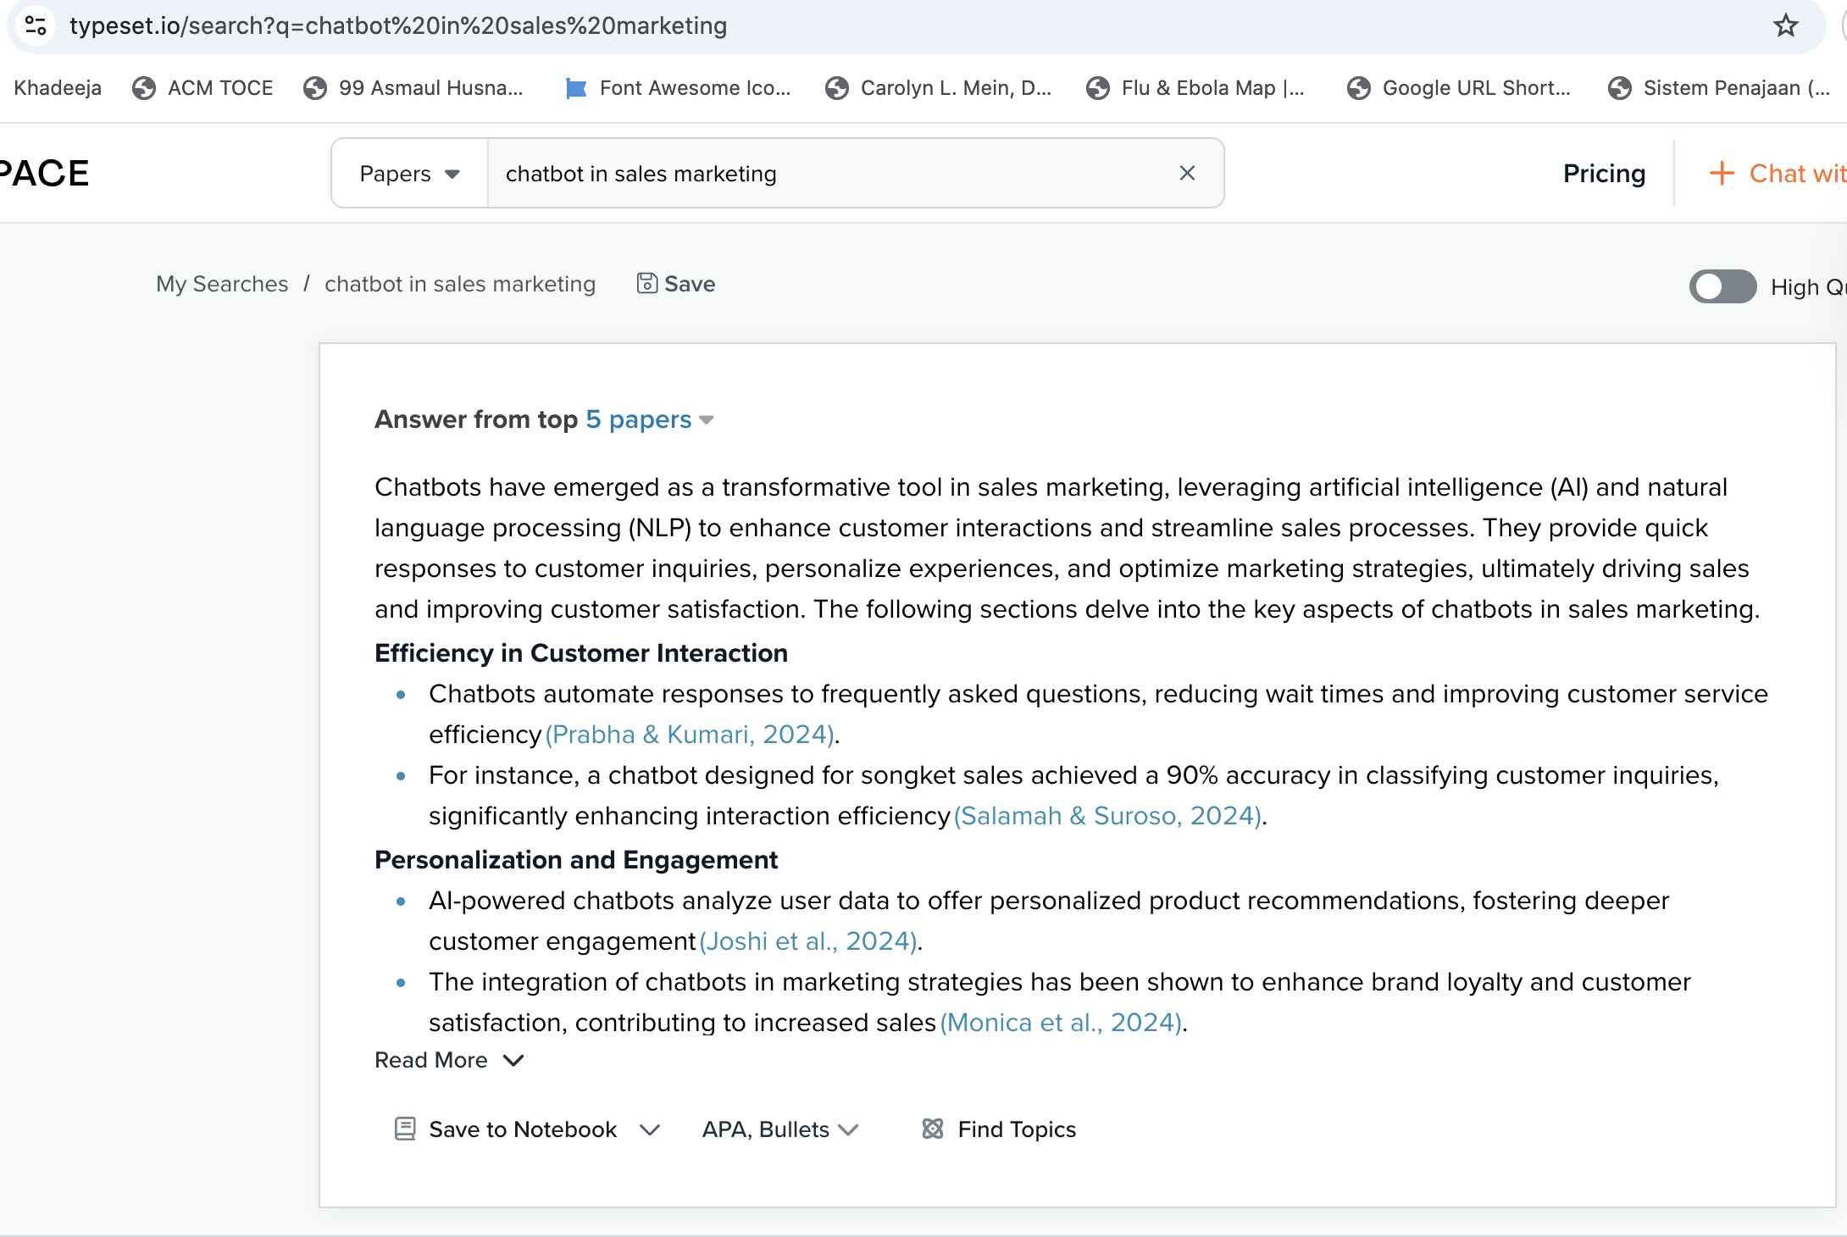

- https://chatgpt.com/share/678f1382-c1f8-800b-8b40-cc08fba8a71f

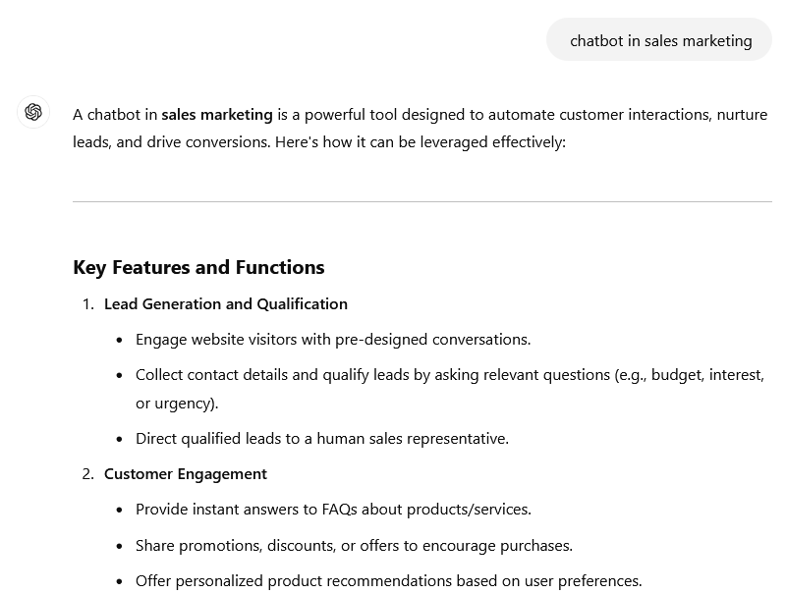

Examples of Effective Prompts (Excellent-scale rubric)

- https://typeset.io/search?q=How%20do%20chatbots%20enhance%20customer%20engagement%20and%20conversion%20rates%20in%20sales%20and%20marketing%3F

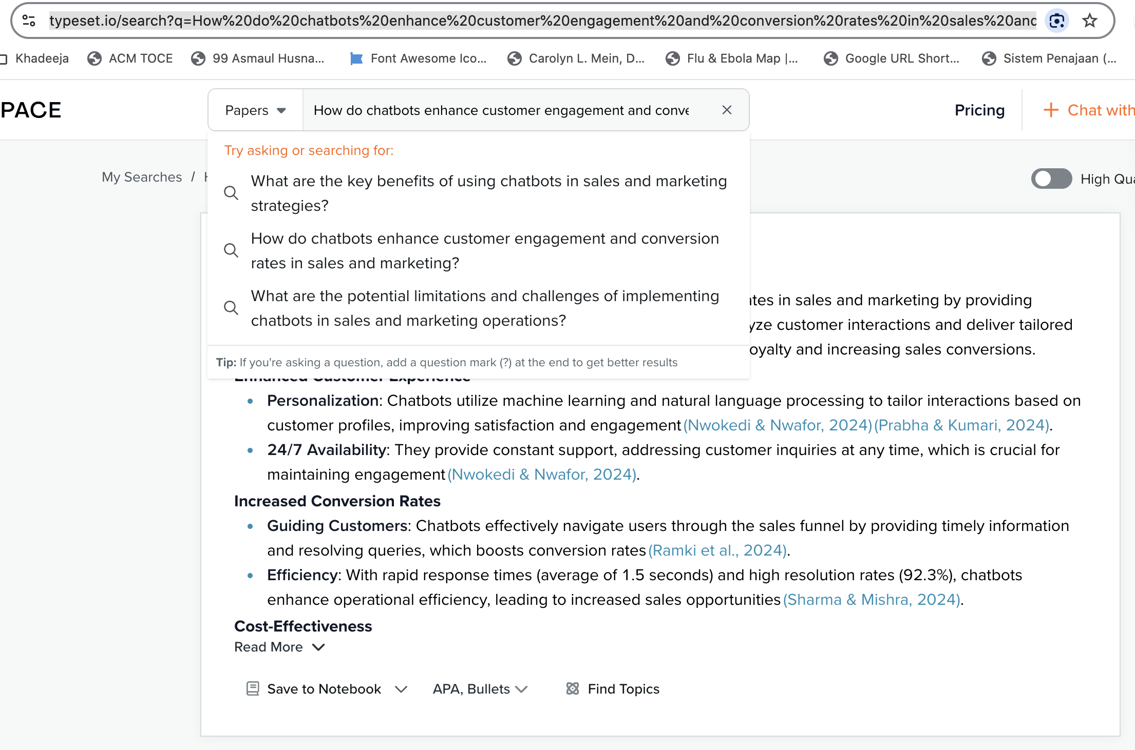

- https://chatgpt.com/share/678f14ad-cf80-800b-98f7-1b0207359450

