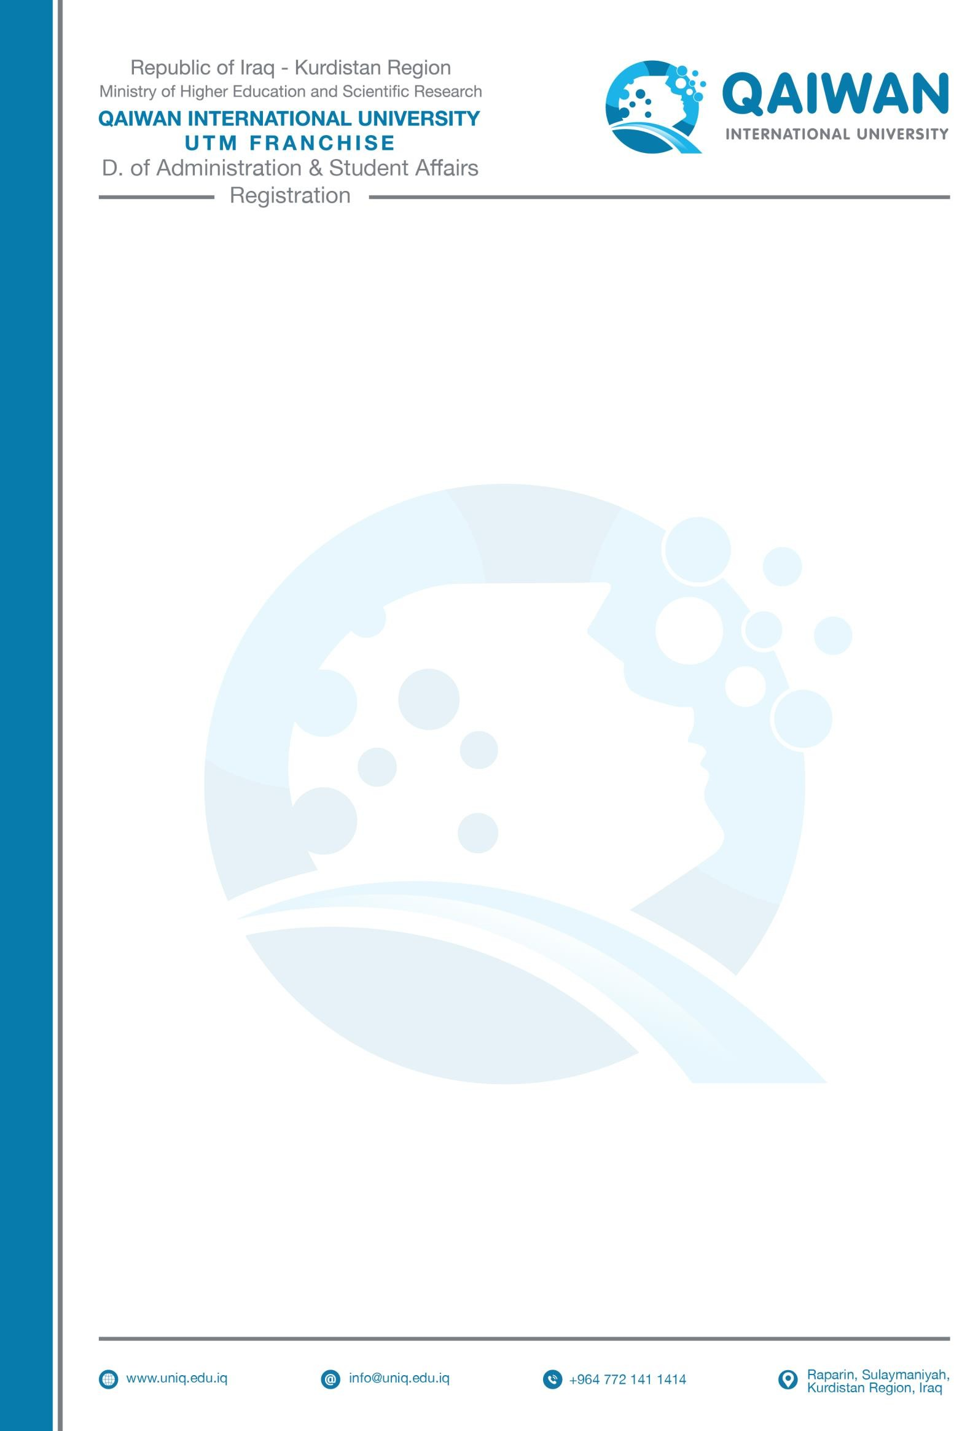

ABESENTESSEM PLEDGE FORM

Student Name |  | :
Student ID |  | :
Department |  | :
Absent Course(s)
# | Course Code | : | Course Name
1 |  | :
2 |  | :
3 |  | :
4 |  | :
5 |  | :

I will attend all classes (s) every day from ………/……. / In addition, arrive promptly
to all classes.
According to the university regulation and rules absence policy, students who reach 20% of absence in each course will be barred from the final exam, if I failed to attend classes, I will be responsible for my absence and, I understand that I will be barred in the final exam if my absence percentage reaches more than 20%.

Student Name: Lawyer Name: Dezhin Najmadin Ali
Student Signature Lawyer Signature:
Date: Date:

- This MUST be filled out directly until (3) days, if any student fail to fill out the form after (3) days academic division has right to barre the student from the final exam.
- The form needs to be return to the Academic Division (F1-01) by the faculties.

